

Team Name:- R34 .  
Team Leader Name:- Pariansh Mahajan.  
College Name:- Thapar Institute of Engineering and Technology, Patiala.  
Theme Name:- SDG-8 , Decent work and Economic growth.

Problem Statement :-

As we know, the increasing boost in share market investment and trading among people and have very good outcomes in the field of economic growth. But as we know that the companies which are quite active have their shares at very high price, and the companies having shares at low cost have probably negligible activeness. So in order to make beneficial outcomes, we have to invest large amount of money for the shares of good active companies. But the thing is, an inexperienced person will find it risky to invest money due to fear of loss. He/She do not want to take risks as they don,t know how these things works. This is the biggest hindrance in this field.

Solution :-

So we will create a platform in which we replace the money with raise points.

Raise points are juss like money but not real or can’t be used anywhere. It is a type of score of a user. The thing is that we will provide our user facility and environment juss like the actual share market and trading. Every rise and fall in share price and market, we will convert it to raise points so that our user can face real time difficulties. It will provide experience to the user and the idea like how to invest, how much to invest and he/she is learning and investing in the fake world of share market without even risking any money. Once they gain confidence that now he/she can really invest, it will be really beneficial for economic growth.

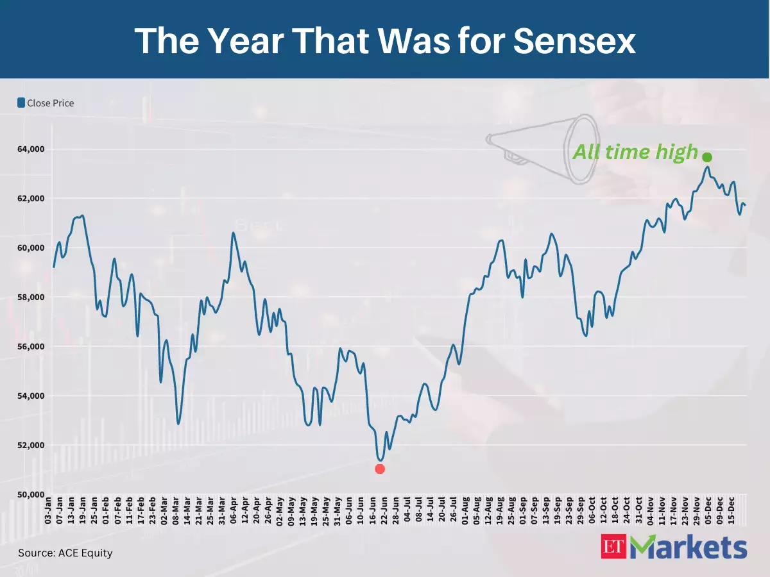

As we see in these graph the shares of ET Markets, in our platform, we will keep updating these shares and prices in form of raise points. And hence create a pseudo environment of trading.

Each user will be provided with 5000 raise points. If he/she loses points enough not to invest again. He/she will have to wait for a certain time limit till it recharges the raise points again. Or we will have another option of buying points with cash too.

Main Aim :- To build the confidence among the people to invest their money. And to provide them experience without RISKING ANY MONEY.

TECHNOLOGY STACK :- Frontend (HTML, CSS, REACT JS, BOOTSTRAP)

Backend (NODE JS, EXPRESS JS, MONGO DB, Django etc..)

Flutter, Block-chain.

**Team Members**

1. Pariansh Mahajan (7876768113) ([parianshm@gmail.com](mailto:parianshm@gmail.com))
2. Adrija Sen Gupta (85840 78092) ([asengupta_be22@thapar.edu](mailto:asengupta_be22@thapar.edu))
3. Aditya Sapra (94655 25702) ([asapra_be22@thapar.edu](mailto:asapra_be22@thapar.edu))
4. Rhitam Dutta (88473 65039) ([rdutta_be22@thapar.edu](mailto:rdutta_be22@thapar.edu))